What do meteorologists use to predict the weather?
- __________________________
- __________________________
- __________________________
What is a weather satellite?
- Used to monitor the _____________________ and ___________________ of the Earth.
- They can see:

  - clouds and cloud systems
  - city lights
  - fires
  - effects of pollution
  - ____________
  - sand and dust storms
  - _________________
  - ice mapping
  - boundaries of ocean currents
  - etc.
What is radar?
- An electronic instrument, which determines the ___________________ and _________________ of objects that reflect radio energy back to the radar site.
- Meteorologists use it to see ____________________________
What is Doppler Radar?
- Detects
  - precipitation _____________________,
  - wind direction and speed, and
  - provides estimates of hail size and rainfall amounts
What are weather Stations symbols?
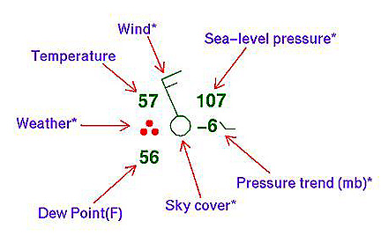
Weather symbols are used on my weather maps as shorthand for the conditions at weather observing stations.

What is a High Pressure System?
- A whirling mass of _____________, _________ air.
- Generally brings fair weather and light winds.
- When viewed from above, winds spiral out of a high-pressure center in a ___________________ rotation in the Northern Hemisphere.
- They bring _____________ _____________.
- Represented by a big, blue H

What is a Low Pressure System?
- A whirling mass of ______________, ____________ air.
- Generally brings stormy weather with strong winds.
- When viewed from above, winds spiral into a low-pressure center in a __________________________ rotation in the Northern Hemisphere.
- Represented by a big, red L

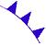
What is a cold front?
- A boundary between two air masses, one ___________ and the other _____________, moving so that the colder air replaces the warmer air.
- Represented as a blue line with the teeth pointing toward the direction of movement.

What is a warm front?
- A boundary between two air masses, one ___________ and the other _____________, moving so that the warmer air replaces the cooler air.
- Represented as a red line with half circles pointing toward the direction of movement.

What is a stationary front?
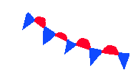
- A boundary between two air masses that more or less do not ______________.
- Represented as an alternating warm and cold front symbol.

What is an occluded front?
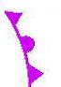
- A combination of two fronts that form when a cold front catches up and _________________ a warm front.
- Represented by a purple line with teeth and half circles.

