Volcanoes and Earth’s Moving Plates
- Volcano – a mountain built from the products of eruption with a central vent
- ______________ - an opening in earth’s surface which molten rock is released
- ______________ - molten rock that has extruded onto the Earth’s surface
- ______________ - molten rock below the Earth’s surface
- Volcanoes can kill people, destroy property, and disrupt the _________________________.
- Lava and ______________________ flows can bury cities and towns in their paths.
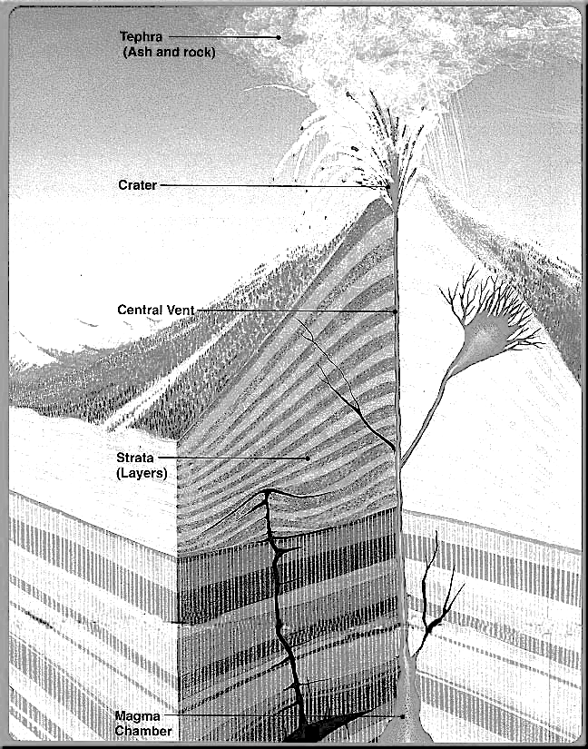
- Sulfurous gases from volcanoes can create ________________________, which can kill organisms and pollute water.
- Parts of a Volcano
- ___________________________ - open space that contains a large quantity of magma.
- _______________ - circular depression at the top of the mound
- _______________ - pyroclastic debris cloud
- _____________________
    - Forms when volcano stops erupting
    - Magma hardens in vent
    - Cone erodes
    - Example: Devils Neck in Wyoming
Where do Volcanoes form?
- At _____________________ Boundaries
  - Plates are moving ____________, forming rifts. Lava flows from these rifts and cools quickly by sea water
  - Forms _____________ seafloor or can build up to form Islands
  - Example: Mid Atlantic Ridge
- At _____________________ Boundaries
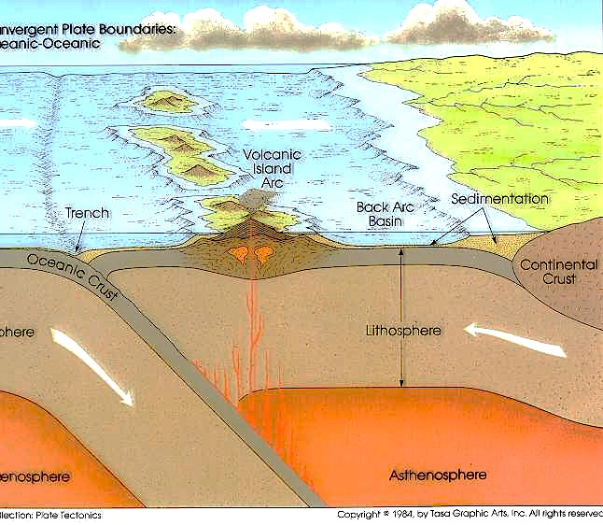
  - Plates are moving together
  - Magma forms when another plate subducts and melts
  - Magma is forced ________________
  - Tend to be more violent
    - Example: ___________________________ chain of volcanoes over the Pacific ocean
  - _________________________ are volcanic islands that form parallel to ocean trenches in subduction zones.
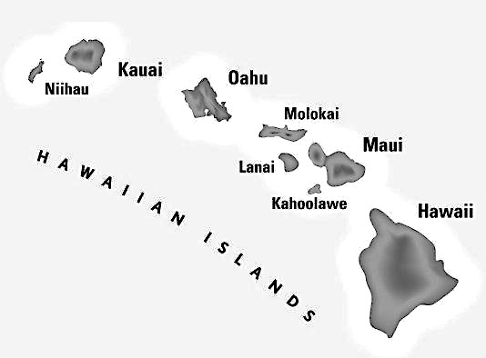
- At ______________________
  - Not formed at plate boundaries
  - Some areas between Earth’s mantle and core are usually hot
  - Hot Rock at these areas is forced towards crust
    - Example: Hawaiian Islands
  - Why are Hawaiian Islands in a row?

Types of Volcanoes
- The amount of water vapor and other ____________________ present is one factor that determines whether a volcanic eruption will be quiet or explosive.
  - Gases can be __________________ in magma by pressure surrounding magma and rock; eventually they will cause an explosive eruption.
  - Magma at convergent plate boundaries can contain a lot of ______________ that can cause explosive eruptions.
- The _______________________ of magma is a second factor affecting the nature of a volcano’s eruption.
  - Low-silica magma, called ___________________, is fluid and produces a quiet, non-explosive eruption.
    - Pahoehoe lava runs down the side of a volcano.
    - Aa lava is a stiff, slow moving lava.
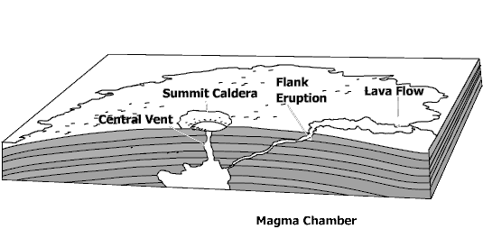
  - High-silica magma called granitic and intermediate silica magma called andesitic produce ______________________ eruptions.
- ______________________ Volcano
  - Broad Volcano with gently sloping slides
  - buildup of layers of basaltic ___________
  - Example: Hawaiian Islands
- ______________________ Volcano
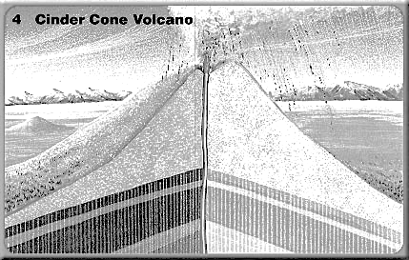
  - _____________ cone shaped volcanoes
  - Forms from explosive lava that falls back to the _________________ and hardens

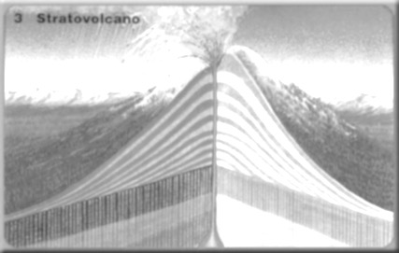
- ______________________ Volcano
  - Also called stratovolcano
  - Found mostly at ____________________ boundaries
  - Most explosive
  - Steep sides

Igneous Rock Features
- Many intrusive igneous features form underground and are later exposed.
  - Batholiths – rock bodies formed when magma bodies that are forced upward from inside Earth cool ________________ and solidify before reaching the surface
  - _____________________--magma that hardens after being forced into a crack cutting across rock; sill-magma that hardens after being forces into a crack _______________________ to rock layers
- A ____________________________ forms when the cone is eroded away, leaving the solid igneous core.
  - _______________________-large depression formed when the top of a volcano collapses
  - _______________________ and erosion wear down surface rock and expose igneous rock features.

