Names: _____________________________________________________ Period: _____________
Pacific Rim
Ring of fire & Hot Spots
Objectives:
- Students will plot the locations of Earthquakes and Volcanoes on a Pacific Ocean map.
- Students will review longitude and latitude.
- Students will observe patterns of Earthquake and Volcano locations.
Procedure
- On the outline of the continents surrounding the Pacific Ocean, using one color, plot the latitude and longitude readings for the volcanoes listed in Figure 1 with a dot. Some may be very close to others.

- Now use a second color to plot the latitude and longitude for the earthquakes listed in Figure 2 using a dot. Some may be very close to other dots or in the same locations.

- When you have completed locating all of the volcanos and earthquakes, shade a line of best fit in red to reveal the Ring of Fire.

- Answer the Analysis and Conclusion Questions below.

Analysis and Conclusion
- How are earthquakes distributed on the map? Are they scattered evenly over the Pacific Ocean? Are they concentrated in definite zones?

- How are volcanoes distributed? Are they scattered evenly or concentrated in zones?

- Why are there spots in the middle of the Pacific Ocean that are not connected.

- From your data, what can you infer about the relationship between earthquakes and volcanoes?

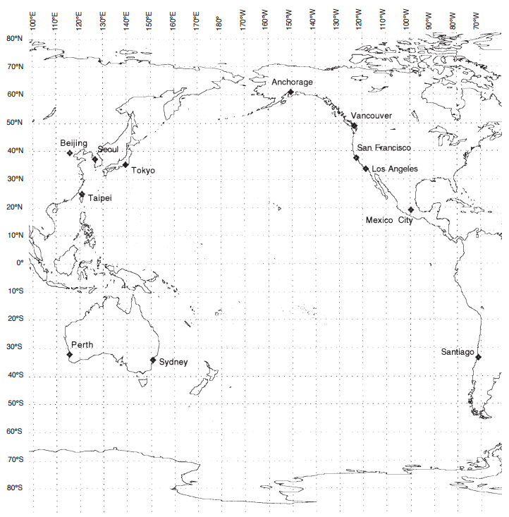

Figure 1: Readings for volcanoes.
Volcano Name | Location | Latitude | Longitude
1. Ngauruhoe | New Zealand | 38° S | 178° E
2. Lamington | Papua, New Guinea | 5° S | 152° E
3. Rabaul | Bismark Archipelago | 5° S | 152° E
4. Soputan | Swlawesi | 3° S | 120° E
5. Apo | Philippines | 7° N | 125° E
6. Pinatubo | Philippines | 7° N | 125° E
7. Usu | Japan | 43° N | 143° E
8. Fuji | Japan | 36° N | 138° E
9. Kuril Islands | Russia | 47° N | 153° E
10. Klyuchevskoi | Russia | 55° N | 160° E
11. Mt. Katamai | USA (Alaska) | 56° N | 162° W
12. Mt. Spurr | USA (Alaska) | 61° N | 144° W
13. Nouarupta | USA (Alaska) | 60° N | 138° W
14. Mt. St. Helens | USA (WA) | 46° N | 122° W
15. Mt. Shasta | USA (CA) | 41° N | 122° W
16. Cerro de la Encantada | Mexico (Baja) | 30° N | 115° W
17. Colima | Mexico | 20° N | 103° W
18. San Cristobal | Nicaragua | 18° N | 87° W
19. Pacaya | Guatemala | 14° N | 92° W
20. Poas | Costa Rica | 10° N | 85° W
21. Cotopoxi | Ecuador | 0° | 78° W
22. El Misti | Peru | 10° S | 77° W
23. Carro Azulfe | Chile | 27° S | 69° W
24. Maipo | Argentina | 34° S | 70° W
25. Antuco | Chile | 38° S | 69° W
26. Mauna Loa | USA (Hawaii) | 19.4795° N | 155.6027° W
27. Kilauea | USA (Hawaii) | 19.4211° N | 155.2868° W
28. Lō’ihi | USA (Hawaii) | 18.54° N | 155.27° W
29. Hualālai | USA (Hawaii) | 19.4132° N | 155.5202° W
30. Mauna Kea | USA (Hawaii) | 19.49° N | 155.28° W

Figure 1: Readings for earthquakes.
Location | Date | Magnitude | Latitude | Longitude
1. Chile | 5/22/1960 | 9.5 | 39° S | 73° W
2. Prince William Sound, Alaska | 3/28/1964 | 9.2 | 61° N | 148° W
3. Sumatra-Andaman Islands | 12/26/2004 | 9.1 | 3° N | 95°E (Do not plot)
4. Honshu, Japan | 3/11/2011 | 9.0 | 38°N | 142°E
5. Kamchatka | 11/4/1952 | 9.0 | 53° N | 160° E
6. Arica, Peru (now Chile) | 8/13/1868 | 9.0 | 18° S | 70° W
7. Cascadia Subduction Zone | 1/26/1700 | 9.0 | 49° N | 125° W
8. Bio-Bio, Chile | 2/27/2010 | 8.8 | 35° S | 72° W
9. Esmeraldas, Ecudaor | 1/31/1906 | 8.8 | 1° N | 80° W
10. Rat Islands, Alaska | 2/4/1965 | 8.7 | 52° N | 178° W
11. Valparaiso, Chile | 8/8/1730 | 8.7 | 33° S | 72° W
12. Andreanof Islands, Alaska | 3/9/1957 | 8.6 | 51° N | 175° W
13. Sumatra | 9/12/2007 | 8.5 | 4° S | 101° E
14. Kuril Islands | 10/13/1963 | 8.5 | 46° N | 151° E
15. Banda Sea, Indonesia | 2/1/1938 | 8.5 | 5° S | 131° E
16. Kamchatka | 3/3/1923 | 8.5 | 54° N | 161° E
17. Chile-Argentina Border | 11/11/1922 | 8.5 | 29° S | 71° W
18. Sanriku, Japan | 6/15/1896 | 8.5 | 39° N | 144° E
19. Lima, Peru | 10/20/1687 | 8.5 | 12° S | 77° W
20. Peru | 6/23/2001 | 8.4 | 16° S | 73° W
21. Sanriku, Japan | 3/2/1933 | 8.4 | 39° N | 144° E
22. Kuril Islands | 11/15/2006 | 8.3 | 46° N | 153° E
23. Hokkaido, Japan | 9/25/2003 | 8.3 | 41° N | 143° E
24. Kuril Islands | 11/6/1958 | 8.3 | 45° N | 149° E
25. Shumagin Islands, Alaska | 11/10/1938 | 8.2 | 55° N | 159° W

