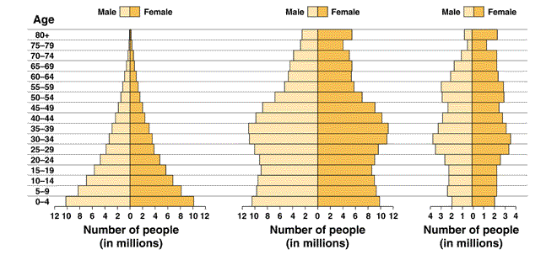

A B C

- Identify which diagram would be associated with Germany, a country with declining growth.

- Identify which diagram would be associated with Nigeria, a country with rapid growth.

- Identify which diagram would be associated with the United States, a country with slow growth.

- Draw a graph showing/labeling exponential growth, carrying capacity, and logistic growth. Label which axes is population size and time.

- What is the definition of carrying capacity?

- What are 3 things that can affect the carrying capacity of a population?

- How do you calculate population growth? natural population growth?

- A change in the size of a population over a given period of time is that population’s _____________________

- When do you have a zero growth rate? negative growth rate? positive growth rate?

- Use the chart below to list the characteristics of developed vs developing countries.
Characteristics of  Developed Countries | Characteristics of  Developing Countries

