Human Population Notes
Vocabulary
_______________________: All the members of a species living in the same place at the same time.
_______________________: Number of individuals per unit area per volume.
_______________________: Relative distribution or arrangement of its individuals within a given amount of space.
_______________________: Average number of children each woman has over her lifetime
__________________________________: A fertility rate that will just replace a women & her partner
_______________________: Number of deaths (infant mortality – infant deaths per thousand live births)
Population Explosion
- Population growing at nearly 80 million people per year!
  - Beginning of human history to 1800s – slow population growth
  - 1830 – world population was 1 billion
  - 1930 – world population doubled - 2 billion
  - 1960 – world population at 3 billion
  - 1975 – world population at 4 billion
  - 1999 – world population at 5 billion
  - 2008 – 6.7 billion people
- Putting the numbers in perspective:
- Each time your heart beats, 3 more people are added to the world -OR- Each time a person dies, 2.8 babies are born
Reasons for the Explosion
- Prior to 1800s populations were kept in check by
  - ________________________ (smallpox, measles, scarlet fever)
    - Infants/children died often
  - __________________ of diseases (black plague, typhus, cholera)
- 1800s and on –
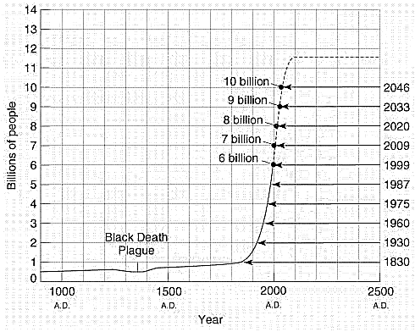
  - __________________ advances were made, discovery that diseases were caused by infectious agents (bacteria, viruses, parasites)
  - Improved hygiene
  - Technology
  - Medicines (penicillin – 1930 & other antibiotics)
  - Better sanitation
  - Knowledge of nutrition
Overall:
- Better recruitment resulted from declining infant mortality rates
- __________________ rates decline:
  - Improvement in ___________________ increased production and better food distribution and storage
  - Public health measures _________________ sanitation practices, clean drinking water, mass inoculations
Note: Human populations may overshoot the earth’s ________________________________ because of our ever increasing use of technology. ________________________ is allowing us to change the environment, extend the average lifespan and help those that would have normally died live.
Rich & Poor Nations (Developed vs. Developing)
- 3 Classifications for Countries
  - _________________________, highly developed, industrialized countries
  - _________________________, moderately developed, countries
  - _________________________ countries
- Developed Countries
  - High-income, highly developed, industrialized -globalized countries
  - 20% of world’s population / 80% of world’s wealth
    - _________________ birth rates
    - Low to negative growth rates
    - Increased ______________________ rates per person
    - Negative environmental impact due not to numbers but affluence.
      - Consequences of affluence
        - Greater contribution per person to global pollutants, carbon dioxide, ozone depletion chemicals
        - Food consumption high on biomass pyramid - fewer people can be supported
        - Waste production high fuel inefficient transportation & throwaway consumer goods.
  - US, Canada, Japan, Australia, New Zealand, western Europe, Scandinavia, Israel, Singapore
- Developing Countries
  - Middle-income, moderately developed & low-income countries
  - 80% of world’s population, 20% of world’s wealth
    - ________________ birth rates (these rates have decreased in the last 20 years)
    - Moderate to high growth rates
    - Low consumption rates per person
    - ___________________ environmental impact due to numbers not affluence
      - Consequences of population size:
        - Subdividing farms and intensifying cultivation
        - Opening up new lands for agriculture
        - Migration to cities
        - Illicit activities
        - Emigration and immigration
        - Impoverishment of women and children
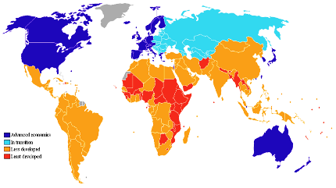
  - Middle – Latin America, northern & southern Africa, eastern Asia, eastern Europe, former USSR, China & India are shifting
  - Low – eastern, western, central Africa, central Asia
- Compare & Contrast
Developed Countries | Developing Countries
World Consumption Classes
Category of Consumption | Rich  (1.2 Billion) | Middle  (3.6 Billion) | Poor  (1.2 Billion)
Diet | Meat, packaged food, soft drinks | Grain, clean water | Insufficient grain, unsafe water
Transport | Private Cars | Bicycles, buses | Walking
Materials | Throwaways | Durables | Local biomass

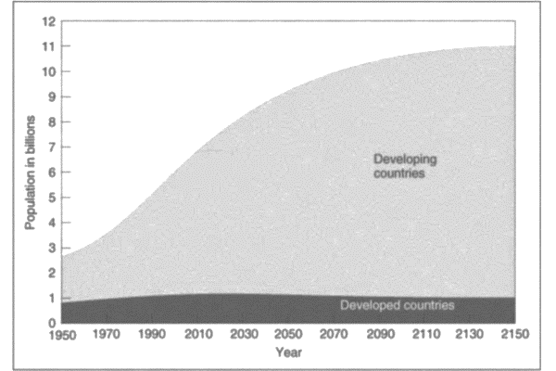
Population Growth: Developed vs. Developing Countries
- 99% of the world’s population growth is occurring in the ____________________ countries!
- ________________ rates dropping in developed and developing countries, but are still much higher in developing countries.
  - 2.1 in developed countries
  - 3.2 in developing countries (these countries populations will double in just 20-40 years at this rate)
- By 2075 it is expected that 90% of the world’s population will be in ______________ countries
Environmental Impacts: Developed vs. Developing
- The impact that each individual will make on the environment depends on the level of _____________________ & the ___________________ needed for consumption
- ___________________ impacts on the environment will increase as consumption increases
- Developing Countries
  - ______________ to the industrial revolution developing countries:
    - Relied on subsistence agriculture (grow only what is necessary to survive)
    - Families lived on the land
    - Natural forests provided energy, housing materials, and habitat for wild game (meat)
    - Agricultural practices were passed from one generation to the next
  - ______________ Industrial Revolution developing countries:
    - Were introduced to modern medicine (vaccines & antibiotics)
    - Death rates dropped
    - Populations grew rapidly
  - 5 things happened as a result:
    - Farms were subdivided among children
    - New lands were opened up to farm
    - People moved to cities for employment
    - Illicit activities increased for income
    - Emigration to other countries (legal & illegal)
- Impoverished Woman & Children
- Men take little to no responsibility for women they get pregnant or their children that are born (very few welfare systems)
- ________________ forced to beg & steal
- 20 million “stray” ______________ in the cities of developing countries
- _______________ child labor, child prostitution, selling children for adoption
- Vicious cycle of illiteracy & inhospitable living conditions
- Consequences of a Population Explosion in Developing Countries
- ________________________:
- Clean drinking water, sanitary sewage systems, sewage treatment, collection & disposal of refuse
  - Results in: decreased pollution
- Affordable gas & electricity
  - Results in: not destroying woodlands for firewood
- Affordable/better agricultural practices
- ____________________
- Use large quantities of fossil fuels (coal, oil, natural gas)
  - Results in: U.S. producing ~25% of CO2 emissions (only 4.5% of world’s population)
- Use/Used large quantities of CFCs (chlorofluorocarbons) that degrade the ozone layer.
  - Results in: whole in ozone layer; more UV rays to earth
- Emissions of sulfur & nitrogen oxides
  - Results in: Acid Rain
- 86% of private consumption/80% of world trade
  - Results in: 11 of the 15 major fisheries are fully exploited or overexploited, old growth forests are clear cut for paper products/furniture/etc, oil spills/drips, illegal species trade
- Waste disposal at distant locations
  - ______________ (not in my backyard)
- Obtaining resources from distant locations
Dynamics of Population Growth
- To determine population growth, look at:
  - ______________________________________________________________________________________________________________________________________________
- Population Profiles/Histograms
  - Bar graph that shows the number or proportion of people at each age for a given population
  - ____________________: the proportion of people in each age group at a given date
Histograms
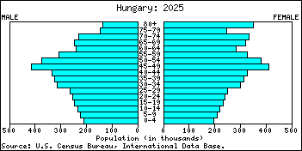
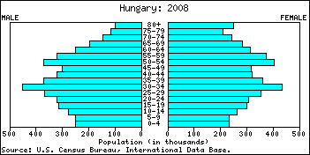
Developed Countries = Slow to No Population Growth

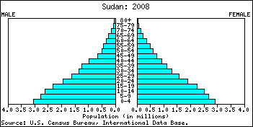
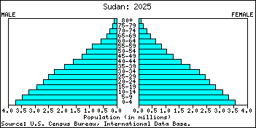
Developing Countries = Fast or Very Fast Population Growth

Population Projections
- ___________________ Technique:
  - Estimating population growth/decline. Subtract deaths from births = absolute change in the size of the population
- Estimating ____________:
  - Multiply the number of women of reproductive age by the percent who have babies.
- Estimating ____________:
  - Use insurance companies life insurance data (not reliable in developing countries)
- ___________________________
  - Low fertility rates
  - Less than 20% of population below 15
  - Population “Graying” – proportion of elderly people is increasing
  - Populations slow down & stabilize. Some countries are seeing a decline, what does this mean for their country?
- __________________________
  - Fertility rates are generally dropping, but still well above replacement level (~3.2)
  - Histograms typically have a pyramid/triangle shape
  - Have very young populations
  - 40%-50% of population is below 15 years old
  - Massive population growth
    - More schools, housing, hospitals, roads, sewage collection, energy, etc
  - Example Iraq:
    - By 2025 population will increase from 23 to 40 million. Housing and all other facilities will have to be doubled in 25 years.
Population Momentum
- When a population continues to grow even after the total _____________ rate is reduced to the replacement level.
- B/C there is a very small proportion of the population in the upper age groups where deaths occur, but a very high proportion of the population entering their reproductive years.
- Only a population at or below replacement level for many decades will achieve a ______________ population.
The Demographic Transition
- As economic development occurs society moves from primitive population stability (high birthrates & high infant mortality) to modern population stability (low birthrates & low infant mortality)
- Modernization leads to a decline in birth & death rates!
Birth & Death Rates
- __________________ (CBR): number of births per 1,000 of the population per year
- __________________ (CDR): number of deaths per 1,000 of the population per year

- Divide this number by 10 and you have the percent rate of growth.
- Stabile population has equal CBR & CDR
Doubling Time
- _____________________ (# of years it takes to double the population)
- To determine – divide the percentage rate of growth into 70.
- Example:
  - World Population Data from 2000:
    - CBR = 22
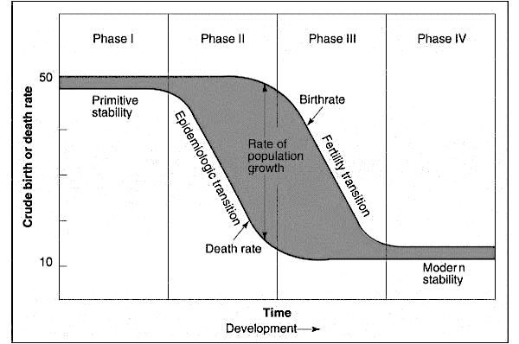
    - CDR = 9
Phases of Demographic Transition
- 4 phases
  - ________________: primitive stability – high CBR offset by high CDR
  - ________________: declining CDR (epidemiologic transition), high CBR, population growth
  - ________________: declining CBR, still declining CDR, population still growing
  - _______________: modern stability, low CBR and low CDR

