Forces Inside Earth
- When rocks break, they move along _________________.
- Faults occur because forces inside the Earth cause Earth’s __________________ to move placing stress on or near the plate edge.
- Rocks will bend, compress, ________________, and possibly break.
- ________________________ - vibrations produced by breaking rock
- Rocks break, move along the fault, return to original _________________
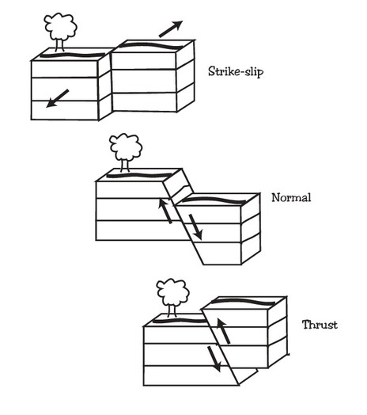
- Rock on one side of a fault can move over, under, or _______________ each other along fault lines.
- Three types of _______________ act on rocks – tension, compression, and shear.
- Tension forces; _________________ fault – caused by rock above the fault moving downward in relation to the rock below the fault.
- __________________ fault – compression forces squeeze rock above the fault up and over the rock below the fault.
- Created by sheer forces; ___________________ fault – rocks on either side of the fault move past each other without much upward or downward motion.
Features of Earthquakes
- _______________________ - waves generated by an earthquake can move the ground forward or backward, up and down, and side to side.
- Focus – an earthquake’s point of ___________________________
- _____________________ waves (P-waves) – cause particles in rocks to move back and forth in the same direction that the wave is traveling
- _____________________ waves (S-waves) – cause particles in rock to move at right angles to the direction of travel
- ________________ waves – move rock particles in a backward, rolling motion and a sideways swaying motion
- The point of the Earth’s surface directly above the earthquake’s focus is called the ____________________.
- The different _________________ of seismic waves allow scientists to determine the epicenter.
- _____________________ waves move fastest.
- Secondary waves follow.
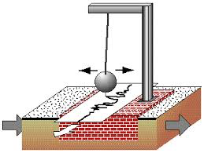
- Surface waves move _______________________ and arrive at the seismograph station last.
- ____________________________ - measures seismic waves
- Consists of as rotation drum of paper and a pendulum with an attached _____________.
- The paper record of a seismic event is called a ______________________.
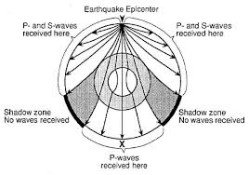
- Earth’s structure
- A seismic wave’s speed and direction change as the wave moves through different layers with _____________________.
- Density generally _____________________ with depth as pressures increase.
- ____________________________________ do not receive seismic waves because the waves are bent or stopped by materials of different density.
- Changes in seismic wave ______________________ allowed detection of boundaries between Earth’s layers.
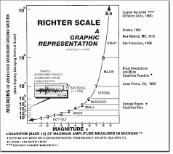
People and Earthquakes
- Although earthquakes are natural geological events, they kill many people and cause a lot of _____________________.
- __________________________ - scientists who study earthquakes
- Magnitude – measure of energy released by an earthquake; determined by the _________________________ and based on the height of the lines on a seismogram
- The Richter scale has no ___________________ limit.
- Most earthquakes have magnitudes too _______________ to be felt by humans – 3.0 to 4.9 on the Richter scale.
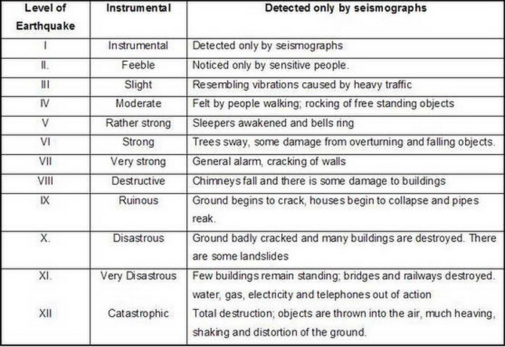
- The modified ____________________ intensity scale describes earthquake intensity based on structural and geologic damage.
- _______________________ - shaking from an earthquake can make wet soil act like a liquid.
- Ocean waves caused by earthquakes are called ________________.
- Caused by sudden movement of the ocean floor ________________ against the water
- Can travel thousands of ______________________ in all directions
- Earthquakes cannot be reliably ______________________.
- Knowing how and where to ______________ for earthquakes can help prevent death and damage.
- Buildings can be ______________________ to withstand seismic vibrations.
- Flexible, circular, _____________________ are being placed under buildings; made of alternating layers of rubber and steel.
- The rubber acts like a cushion to absorb earthquake’s waves.
- Homes can be protected by careful placement of heavy objects and securing __________________ appliances.
- During an earthquake, crawl under a sturdy table or desk; outdoors, stay away from ____________________ and power lines.
- After an earthquake, check for water or gas line damage; leave ____________________ if a gas smell is present.

