Climate and Climate Change ppt Worksheet
Objectives:
- describe the transfer of energy between atmosphere, land masses, and oceans
- describe differential heating and cooling
- describe oceanic and atmospheric circulation patterns
- describe climates and microclimates

Important Vocabulary:
- climate
- weather
- microclimate
- latitude
- differential heating and cooling

Climate
- Climate is the ______________________ prevailing conditions at a particular place taken over time and based on records taken.
- Includes average ____________________ and _____________________ over time.

Weather
- Weather is the _______________ atmospheric conditions at a given time.

Factors that Determine Climate
1. _____________________
2. Atmospheric circulation patterns
3. __________________ circulation patterns
4. Geography of an area
5. Solar activity

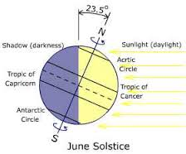
Latitude
- Latitude is the ________________ from the _________________ measured in degrees north or south.
- Light rays strike the earth more __________________ at the ______________ so the equator is ________________ than areas in the northern and southern hemisphere where the sun strikes the earth at an angle.

REMEMBER THIS!!!
- Weather is the atmospheric conditions on ________________________.
- Climate is the ____________________ weather conditions determined by temperature and precipitation.

Microclimate
- A local atmospheric zone where the ____________ differs from the surrounding area is known as a _______________________.
- A microclimate exists inside the bird of paradise flower. The ____________________ is very different on the inside compared to the outside of the flower.
- The term may refer to areas as small as a few square feet or as large as many square miles.
  - __________________
  - __________________
More Examples:
- Bodies of _____________ may _________ the local atmosphere and create a microclimate.
- Heavily urban areas where brick, concrete, and asphalt absorb the sun's energy, heat up, and_______________________ that heat to the ambient air.
  - The resulting ___________________________ is a kind of microclimate.

Factors that affect Climate and Weather
- Land masses and oceans (nearness to oceans)
- Number of days and hours of sunlight
- Air circulation patterns (direction of winds)
- Differential heating and cooling
- Oceanic circulation patterns

Air Circulation Patterns
- __________ air ___________ because it is _____________________ than warm air.
- cold air sinks and then warms
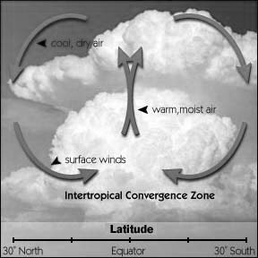
- ___________ air _____________, expands and then cools.
- When warm air cools, water vapor may ________________ to form rain, snow, or fog.

Oceanic Circulation Patterns
- __________________ - winds in the western pacific strengthen and push _____________ water eastward.
- _______________ – __________ water in the eastern pacific gets pushed westward. It is the opposite phase of El Nino.
- As El Nino brings in warm water eastward, and La Nina brings in cool water, the ___________ temperature above is affected and thus affects the temperature on ___________.
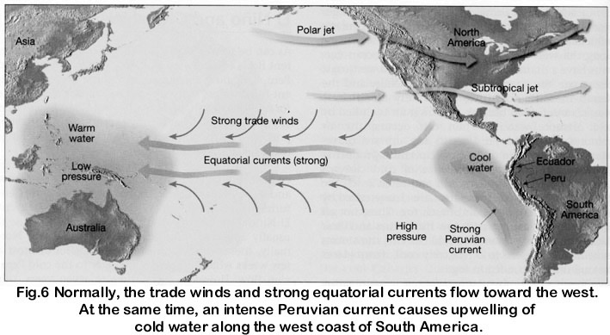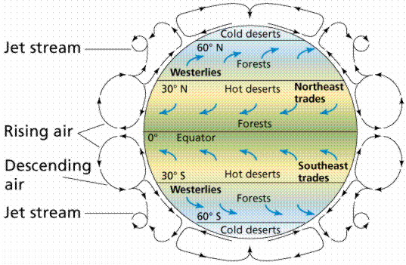

REMEMBER THIS!!!
- Nearness to large bodies of water and ocean currents affects climate.
- Climate determines where plants grow.
- Climate is determined by long range temperature and precipitation patterns.
- Climate determines which organisms are found in a particular area.

Land Masses and Oceans
- Wind blowing over water creates a _________________________ effect.

Rainshadow Effect
- An area having relatively little______________________________ due to the effect of a ___________________, such as a mountain range, that causes the prevailing winds to lose their moisture before reaching it.
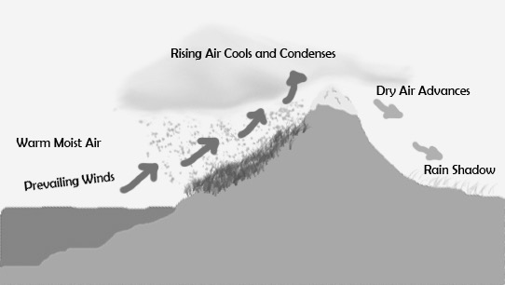
It rains a lot on the side of the mountain _______________ the body of water, but is __________ on the inland side of the mountain.

Differential Heating and Cooling
- _____________ masses heat up more ________________ and cool more quickly than large bodies of _________________.
- Have you ever taken a walk on the dry beach on a sunny day?
  - Did you find that in the early afternoon the sand was much warmer than the water?
  - That’s _______________________________________________!
- Water is a ____________ conductor of ______________, thus it needs to gain ________________________ than the sand or dry land in order for its temperature to increase.
- On the other hand, ___________ loses its heat much _________________.
  - But your toasted toes would perhaps mislead your mind!
- Earth's ________________ are far more important than the land as a source of the heat energy which drives the __________________.
- Not only do the oceans cover more than ____________ of the Earth's surface, they also ______________ more _______________ and _____________ more ____________ than land.
- Additionally the oceans _______________________ longer.
- The Sun's rays also penetrate the oceans to a depth of ____________________, but only heat up the _________ layer of the sand or soil.
- _______________ has to ___________ more energy than the sand (dry land) in order for the temperature to _____________________.

REMEMBER THIS!!!
Differential Heating and Cooling
- Sea heats up slowly and cools slowly.
- Land heats up quickly and cools quickly.

