Climate and Climate Changes
What is Climate?
- Climate is the pattern of weather that occurs in an area over _________________________
- Determines the types of plants or animals that can survive, and influences how people live
- Elements that are averaged to determine climate:
  - _______________,
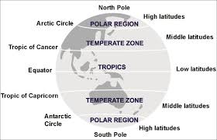
  - precipitation,
  - air pressure,
  - humidity, and
  - days of sunshine
- Factors that affect climate:
- Latitude- distance north to south of the _______________________
  - Tropics (between 23 degrees and 23 degrees south)-sun shines directly overhead, keeping temperatures _________
  - _______________zones (66 degrees north and 66 degrees south to the pole)-sun shines at a low angle, keeping temperatures low
  - Temperate zones (between the tropics and the polar zones)- ________________ temperatures
- Large bodies of water affect the climate of coastal areas by _____________________ or giving off heat.
- Ocean currents can bring cool or warm temperatures and ____________________ to coastal areas.
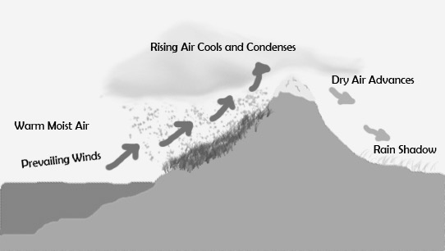
- Mountains affect their own climate as well as the climates of nearby areas.
  - At the same latitude, the climate on a mountain is ______ than the climate at sea level.
  - Mountains cause air to rise, cool, and condense, creating a ________ climate on the windward side of the mountain and a much drier climate on the leeward side.

- Because of their large areas of solar radiation-absorbing pavement, _______ frequently have higher temperatures than surrounding areas.

Climate Types
- Koppen’s system of climate ____________________
- Examine temperature, precipitation, and _____________________
- Six types of climate:
  - tropical,
  - mild,
  - dry,
  - continental,
  - polar, and
  - ____________________
- Adaptation – any structure or behavior that helps an organism ___________________ in its environment
  - _____________________ Adaptations are body structures that help organisms survive in colder climates.
    - Example: the __________ of mammals insulates them from cold temperatures.
    - Example: a cactus’s thick, fleshy _____________ helps it hold water.
  - ______________________ Adaptions
    - Example:____________-a period of greatly reduced activity during cold months
    - Example: estivation-state of __________________, similar to hibernation, that occurs during periods of intense heat

Climate Changes
- Seasons- short periods of climate change causes by differences in the amount of _______________ ________________an area receives.
  - As Earth revolves around the Sun, different areas of Earth are ___________ toward the sun.
  - The ___________________ do not experience much seasonal temperature change.
  - High latitudes near the poles experience _________________ seasonal temperature change.
- El Nino-an occasional climatic event in which strong Pacific winds __________________ or __________________
  - Effects of El Nino:
    - Ocean temperatures near Peru __________________.
    - The position and strength of one of the _______________ may be altered, changing wind and precipitation patterns around the world.
    - Africa and Australia may experience ______________.
  - La Nina- The winds blowing across the Pacific are ___________________ than normal.

- At times in the past, Earth’s climate was much warmer or colder than now.
- Causes of _______________ change can operate over short or very long periods of time.
  - Solar radiation is blocked by larger numbers of solid and liquid ___________________ entering the atmosphere.
    - Catastrophic events such as _______________________________ and ________________ collisions can cause climate change.
    - ______________________ can also cause climate change.
  - Variations in solar radiation, possibly related to the presence of ____________________ can cause climate change.
  - Earth’s movements in space can change the amount of __________________________ reaching it.
    - Earth’s _____________ changes about every 41,000 years.
    - Earth’s ______________ wobbles in space.
    - The shape of Earth’s ________________ changes over a 100,000-year cycle.
  - The movement of Earth’s _____________________________ affects the transfer of heat on Earth.
- Climate changes today
  - Greenhouse effect - heating that occurs when certain gases like __________, __________, and water vapor in Earth’s atmosphere rap heat
  - Global warming - Earth’s average global temperature is rising, possibly due to the increase in ___________________________ in our atmosphere.
  - Human activities affect the air in Earth’s atmosphere.
    - Burning _________________________ increases the amount of carbon dioxide in the atmosphere.
    - _______________________ results in fewer trees absorb carbon dioxide from the atmosphere.
    - Individuals can help reduce the amount of _______________ in the atmosphere.

Typical Pacific Ocean Temperatures/Winds

Pacific Ocean Temperature/Winds During El Niño

