**Fossils**

1. _______________________________ study fossils and reconstruct the appearance of animals.
2. __________________ - remains, imprints, or traces of prehistoric organisms
3. Fossils can form if the organism is quickly _________________ by sediments.
4. Organisms with ____________________ are more likely to become fossils than organisms with soft parts.
5. Types of ________________
6. Fossils in which spaces inside are filled with minerals from groundwater are called _______________________ **remains.**
7. _______________________ results when a thin film or carbon residue forms a silhouette of the original organism; carbonized plant material becomes ______________.
8. ______________ - cavity in rock left when the hard parts of an organism decay
9. If sediments wash into a mold, they can form a _______________ of the original organism.
10. Occasionally _______________ remains are preserved in a material such as amber, ice, or tar.
11. _______________________ - evidence of an organism’s activities
12. Can be ___________________ left in mud or sand that became stone
13. Can be trails or ____________________ made by worms and other animals
14. _________________________ - abundant, geographically widespread organisms that existed for relatively short periods of time
15. Fossils can reveal information about past land forms and ___________________.

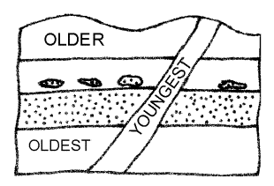**Relative Ages of Rocks**

1. **Principle of** _______________________ - process of reading undisturbed rock layers
2. **_______________** rocks in the bottom layer
3. **_______________** rocks in the top layer
4. How old something is in comparison with something else is its ______________________.
5. The age of _____________________ rocks can be determined by examining layer sequences.
6. 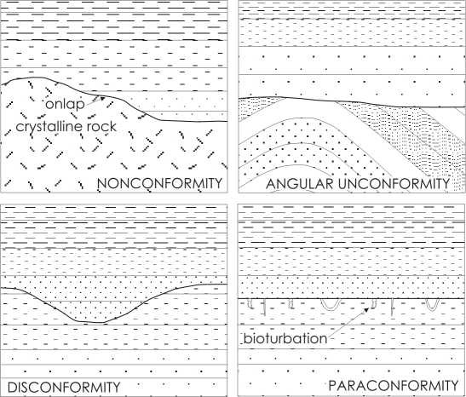The age of undisturbed rocks may have to be determined by _______________ or other clues.
7. _________________________ - gaps in rock layers
8. ___________________ - unconformity – rock layers are tilted, and younger sediment layers are deposited horizontally on top of the eroded and tilted layers.
9. A layer of horizontal rock once exposed and eroded before younger rocks are formed over it is called a ________________________.
10. ____________________ - sedimentary rock forms over eroded metamorphic or igneous rock.
11. 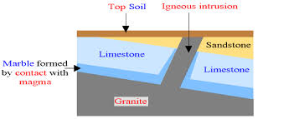The same rock layers can be found in different locations; fossils can be used to ________________________ those rock layers.
12. 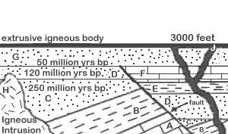Igneous ___________________ occur when magma flows into already existing rock where it cools and hardens.
13. Igneous ____________________ occur when lava flows onto the Earth’s surface and solidifies.

**Absolute Ages of Rocks**

1. _______________________ - age, in years, of a rock or other object; determined by properties of atoms
2. Unstable isotopes break down into other isotopes and particles in the process of _____________________ **decay**.
3. ______________________ - an isotope’s neutron breaks down into a proton and an electron with the electron leaving the atom as a beta particle; a new element forms due to proton gain.
4. ______________________ - an isotope gives off two protons and two neutrons as an alpha particle; a new element forms.
5. The time it takes for half the atoms in an isotope to decay is the isotope’s ________________.
6. Calculating the absolute age of a rock using the ratio of parent isotope to daughter product and the half-life of the parent is called **radiometric** ________________.
7. __________________________ dating is used to date ancient rock millions of years ago.
8. _________________ dating is used to date bones, wood, and charcoal up to 75,000 years old.
9. Earth is estimated to be about 4.5 billion years old; the oldest known rocks are about ___________________ years old.
10. __________________________ - Earth processes occurring today are similar to those that occurred in the past.

**Life and Geologic Time**

1. __________________ time—Earth’s history is divided into time units that make up a **geologic time scale**.
2. Time units on the scale are based on the appearance or disappearance of types of organisms such as _______________, index fossils that lived during specific periods of time.
3. Geologic time is divided into 4 major ____________________.
4. _______ – longest subdivision; based on abundance of fossils
5. _______ – marked by significant worldwide changes in the types of fossils present in rock
6. _____________ – based on types of life existing worldwide at a particular time
7. _____________ – characterized by differences in life-forms, but differences can be regional rather than global
8. Geological time can be subdivided only if fossils are present in rock records.
9. _________________ evolution—Organisms have changed over time, most likely because of environmental changes.
10. **Species**—organisms that normally ______________ only with other members of their group.
11. Darwin’s theory of **natural** ________________ - organisms more adapted to an environment are more likely to reproduce.
12. Natural selection within a species occurs only if characteristics present in some numbers increase their __________________.
13. _________________ selection - breeding individuals with desired characteristics; humans use this type of selection when breeding domestic animals.
14. __________ species can evolve from natural selection.
15. Trilobites – have an exoskeleton with three lobes; lived in oceans for more than 200 million years
16. Trilobite ________ position changed as the species adapted to various environments.
17. Trilobite bodies and _____ changed in response to changing environments.
18. Continental collisions formed the giant landmass ____________ near the end of the Paleozoic ______. These collisions may have dropped________________, causing the extinction of trilobites.

**Early Earth History**

1. _____________________ **time** – from 4 billion to about 544 million years ago
2. Very few_____________ remain from this time.
   1. Many Precambrain rocks were deeply buried, causing the fossils in them to be changed by ____________ and pressure.
   2. Most Precambrain organisms lacked ____________ parts.
3. **Cyanobacteria** are blue-green _____________.
   1. One of the ___________ life forms to appear
   2. Added __________ to the atmosphere through photosynthesis
4. __________________ and Ediacaran animals appeared late in Precambrain time.
5. The _________________ **Era -** about 544 million years ago to about 245 million years ago
6. Many organisms with ____________ and vertebrates evolved in the warm, shallow seas.
7. ________________ evolved to survive in water and on land.
   1. Might have evolved from _________
   2. Could obtain oxygen from ____________ or from lungs.
8. ______________ evolved from amphibians to survive farther from water
9. Several mountain-building episodes occurred during the Paleozoic Era because of _________ collisions.
10. Most marine and land species became _______________ at the end of the Paleozoic Era.

**Middle and Recent Earth History**

1. ________________ **Era-**lasted from 245 to 65 million years ago
2. Pangaea separated into __________________ and the climate became drier.
3. ____________________ evolved; they might have been warm-blooded, traveled in herds, and nurtured their young.
4. _______________, which probably evolved from small, meat-eating dinosaurs, appeared during the Jurassic Period.
5. Small, mouse-like __________________, which are warm-blooded vertebrates with hair and milk to feed their young, appeared in the Triassic Period.
6. **________________,** plants that produce seeds but not flowers, appeared in the Paleozoic Era.
7. Flowering plants or ____________________ appeared during the Cretaceous Period.
8. A great extinction, perhaps caused by a comet or an asteroid collision, occurred about ______________ years ago, marking the end of the Mesozoic Era.
9. The __________________ **Era** began about 65 million years ago and continues today.
10. Many ___________________________ formed, perhaps creating cooler climates worldwide.
11. Mammals continued to evolve
12. Many species became _________________ as the continents continued to separate.
13. *Homo sapiens,* or __________________, appeared about 400,000 years ago.

