Natural Pollutants
1. Volcanoes – SO, _____________________
2. Forest Fires – CO, CO2, NO, ___________________
3. Windstorms - ______________
4. Plants (Live) – hydrocarbons, ________________
5. Plants (Decaying) – ______________________, H2S
6. Soil – viruses, _______________
7. Sea – ________________________

Anthropogenic Pollutants – Human activity products – very concentrated.
1. Carbon monoxide - ____ Vehicles 2. Sulfur oxides - _____ Industry
3. Nitrogen Oxides - _____ Vehicles 4. Particulates – ____ Vehicles, Industry
5. Hydrocarbons – _____ Vehicles, Industry
6. Photochemical oxidants – Formed from the reaction of light and HC and NO. Ground level
Ozone (O₃), Formaldehyde, and Peroxyacylnitrate (PAN) are a few examples.

HUMAN IMPACT
Altering natural balance of cycles in the atmosphere
• Add ____ more carbon dioxide
• Burn fossil fuels releasing ___________ into air = more acid rain (nitric acid)
• Add ________ from burning coal and refining petroleum = more acid rain (sulfuric acid)
• _______________ – 1. 2X the arsenic as nature 2. 7X the cadmium 3. 17X the lead

3 Processes That Cause Air Pollution
1. Combustion – Hydrocarbon (HC) + Oxygen → ______________ + ___________
2. Evaporation – Vaporization of any liquid. ______________, Solvents, etc.
3. Friction – Rubber tires
Primary Pollutants – pollutants released from _____________ sources that may undergo change in the atmosphere and become something more harmful.
Secondary Pollutants – may be more _______________ than the chemicals from which they came from. i.e. sulfur dioxide gas mixing with oxygen and water to become ____________________.

PRIMARY POLLUTANTS SECONDARY POLLUNANTS
1. CO – _________________ 1. SO₃ – ____________________
2. CO₂ – ________________ 2. HNO₃ – __________________
3. SO₂ – ________________ 3. H₂SO₄ – __________________
4. NO – _________________ 4. H₂O₂ – ___________________
5. NO₂ – ________________ 5. O₃ - _____________________
6. Hydrocarbons 6. PAN’s – peroxyacyl nitrates
7. Particulates

Effects Of Climate And Temperature On Air Pollution
1. Gray-Air Cities – _______________, cold moist climates. Sulfur oxides mix with moisture to create _________ – mixture of smoke and fog. Heavily industrialized cities.
2. Brown-Air Cities – __________, non-industrialized cities. Mainly hydrocarbon and nitrogen oxides from automobile and electrical plant pollution. React in the presence of ________________ to form many secondary pollutants.
These reactions are called ________________________________ because they involve chemicals and light.

Photochemical Smog
• __________ cities
• __________ smog
• Mostly ozone, aldehydes, PAN’s, and nitric acid
• Formed from the NOx from cars/factories and volatile organic compounds (VOC’s)
• These VOC’s are methane, propane, benzene, chlorofluorocarbons (CFC’s) mixing in the _______________________

Smog Chemistry
• N₂ + O₂ =2NO __________________ engine of car and then into air to
• 2NO + O₂ = 2NO₂ ________________ brown haze – choking odor to
• 3NO₂ + H₂O = 2HNO₃ + NO _____________ produces acid rain and some NO2 gases go onto
• NO₂ + UV energy = NO + O which then go to
• O + O₂ = O₃ ____________________________

Industrial Smog
• _______________ cities
• _______________ air smog
• Mostly sulfur dioxide and sulfuric acid as well as suspended particles (ASH)
• Mostly caused by ________________________

Smog Chemistry
• S + O₂ = SO₂ __________________________ then to
• SO₂ + O₂ = 2SO₃ ____________________________ then to
• SO₃ + H₂O = H₂SO₄ _________________________ then to
• H₂SO₄ + 2NH₃ = (NH₄)₂SO₄ ____________________ salt and soot give air gray color

Factors Affecting Air Pollution
1. ___________
2. Location
3. _______________
4. Precipitation
5. Temperature Inversion - normal circumstances air temperature falls around ______________________ increase altitude. Pollutants rise and disperse. When a _______________ lid forms over a cooler air, the cooler air cannot rise up through it. Thus the pollutants at ground level increase at ground level.
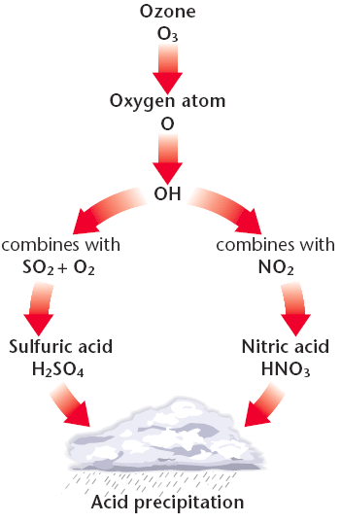
Acid Deposition
- Acid Rain - ___________________
- Acid Deposition – ______________ (solid or gas)
- Natural Rain is _________________ (without acid). CO₂ dissolved from air forms weak ______________.

Acid Rain
- Wet and ______ deposition due to secondary pollutants
- pH of _____ in Eastern US – regional problem
- buffering soil is good – ________________ based
- ______ and below is dangerous – adding lime is least effective
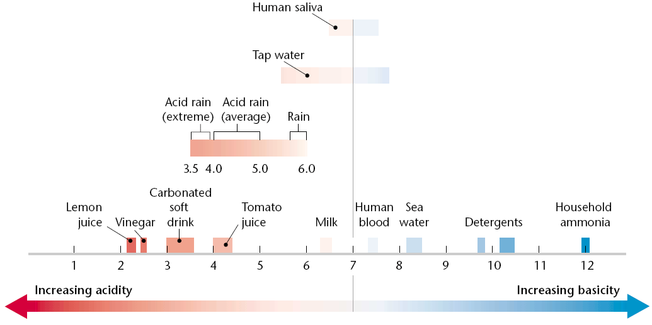

Acid Associated Problems
- Humans – bronchitis, _________________
- Buildings – premature aging
- Trees – weakens leaves, tree becomes vulnerable to pests.
- Soil – releases __________ (toxic) which kill fish when metals run off into water.
- Areas affected are usually _________________ from industrial areas or dense urban zones.
- Vegetation and ___________________________ receive the most damage.

Acid Prevention and Protection
- Natural buffers in soil, _____________ (Ca⁺²) and ________________ (Mg⁺²) can react with and neutralize acids. Thin soils offer no buffer protection.
- Reduce energy use.
- Switch from __________ to cleaner energy source.
- Remove _____________ from coal before burning.
- Remove SO₂, NO_{x}, and particulates from smokestacks with use of ____________.
- Remove NO₂ from _______________________.

Ozone – O₃
- Beneficial in upper atmosphere (stratosphere) – ___________________
- Harmful in troposphere (ground-level) – ______________________
- Causes respiratory problems at ground level.
- _____________ – ozone contributor at ground level
- Only pollutants not reduced in past 30 years – ____________________________
- Atmospheric Ozone is depleted by ____________
- Chloroflorocarbons are found in:
1. _______________________
2. Fire extinguishers
3. Plastic foam containers
4. _______________________
- Cl + O₃ → ClO + O₂
- ClO → Cl + O
- Free Chlorine (Cl) will continue as a _______________ and destroy 100,000’s of ozone molecules.
- Protects us from harmful ____________________ (UV) rays from the sun
- Damage from UV rays include skin cancers, egg formation in aquatic life, and decrease in photosynthesis in plants.

Toxicity
Acute – _________________ – lung irritation, inflammation of respiratory tract, eye irritation, dizziness.
Chronic – _______________ – emphysema, bronchitis, heart attack
Perceived risk – Greater than ______________ risk. Protection is legislated or mandated.
Actual risk – Risk is _____________ than perceived risk. We are generally not concerned.
Toxicity measures how________________ a substance is in causing injury, illness, or death.
Factors that deal with toxicity:
- Dose
- Frequency of exposure
- Age and size of exposed individual
- Health of detoxification system (liver, etc.)
- Genetic make-up

5 factors that can affect the amount of harm a substance can cause
- Solubility – Water or fat ______________
- Persistence – Some ________________ break down, some remain
- Bioaccumulation – Molecules are stored in body.
- Biomagnification – Accumulate at greater levels as you go up ________________
- Chemical Interactions:
Antagonistic – One chemical ____________ effect of another
Synergistic – One chemical _____________ effect of another.

Indoor Air Pollution
- CO - dizziness, headache, heart attack
- asbestos - lung cancer
- NO - lung irritation, asthma
- trichloroethane - aerosols, dry cleaning
- radon - gas from U-238 breakdown
- tobacco smoke - lung cancer, bronchitis, emphysema
- formaldehyde - particle board, furniture
- styrene - carpet, plastics

