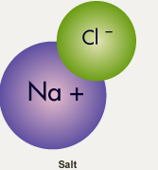
What are the most common elements in sea water?

- Water
  - ______________________
  - ______________________
- Salt
  - ______________________
  - ____________________

Areas of High and Low Salinity
- Of the five ocean basins, the ______________________________ is the saltiest.

Salinity Near the Equator
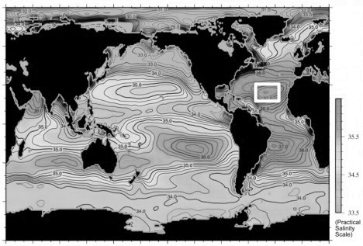
- The tropics receive the _________________ rain, the fresh water falling into the ocean helps _________________________ the salinity of the surface water

Salinity Near the Poles
- At the poles, rain _____________________
- With ________________ rain and more ___________________, evaporation _______________________
- ________________________ of the ice caps causes a _______________________ in the surface salinity.

The Saltiest Locations
- The saltiest locations in the ocean are:
  - Regions where ____________________________ is highest
  - In large bodies of water where there is no _____________________ into the ocean.
  - The _______________________________ and ________________________________ contain the saltiest ocean water due to very high evaporation and little fresh water inflow.

Temperature and Salinity
- As temperature ________________________ to 40ºF (4ºC), molecules slow, water contracts and density __________________________
- Below 40ºF, the molecules begin to bond to each other and as they do, the water begins to expand again, _______________________ the density
- At 32ºF (0ºC), all molecules are locked into a ______________________ structure, causing a __________% expansion in size
  - This expansion, and corresponding ________________________ in density, is the reason ice ____________________
- Adding salt to water lowers the ________________________ temperature
  - Water with a salinity of 17% freezes at about 30°F (-1°C)
  - 35‰ water freezes at about 28.5°F (-2C)
- Sea ice contains very little salt (about 1/10th the amount of salt the sea water has). Why?
- _________________________________________________________________________________________________________________

Temperature, Salinity, and Density
- As temperature of sea water _________________________, density ___________________________.
- As salt content of sea water ____________________________, density _______________________________.
- This makes the density of sea water, unlike fresh water, ________________________ the freezing point.

Average Salinity
- Lowest salinity in the polar regions. Why?

