Seasons
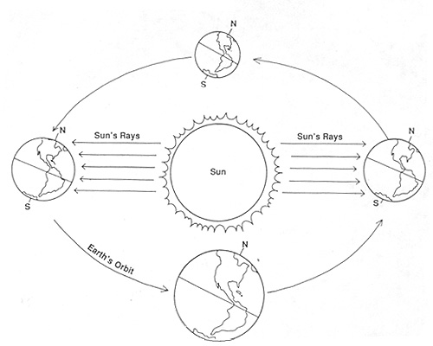

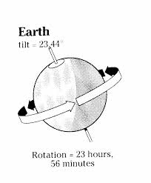
Earth’s Rotation

- The Earth rotates on its axis (imaginary vertical line around which Earth spins) every 23 hour & 56 minutes.
- One _____________________ on Earth is one rotation of the Earth
- ____________________ on Earth is when our side of the Earth faces the sun. ____________________ on Earth is when the side of Earth we are on faces away from the sun.

Earth’s Revolution
- It takes the Earth ____________________ days (or rotations) to travel or revolve around the Earth once.
- This is called a ______________________.

Why do we have Seasons?
- The Earth’s orbit around the sun is NOT a perfect circle. It is an _______________________.
- Seasons are _________________ caused by how close the Earth is to the sun.
- Seasons are the result of the _____________________ of the Earth’s axis.
  - Earth’s axis is tilted __________________

Solstices
- Winter solstice is the ___________________ day of the year in the Northern Hemisphere. It occurs on December 21 and marks the beginning of winter.
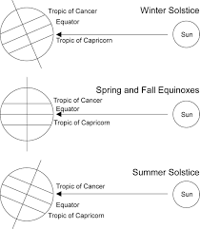
- The Summer Solstice is the ______________________ day of the year it occurs on June 21 and marks the beginning of summer.
- During the winter solstice, the _______________________ has a 24-hour night and the South Pole has a 24-hour day.
- Sunlight strikes the Earth most directly at the Tropic of __________________________.

Equinoxes (translates to equal night)
- A day lasts 12 hours and a night lasts 12 hours at all latitudes.
- Sunlight strikes the Earth most directly at the _____________________________.
- This occurs twice a year.

