Life Processes
- Life began in the ________________
- Organism need _______________ for cell processes
- Where does energy come from?

Photosynthesis
- _______________________ containing organisms capture sunlight
- They make food using sunlight, carbon dioxide, and _______________
- These organisms start food chains
- Coral reefs support _______________________ in warm shallow waters.
- Which zone does this occur?
- Equation?

Chemosynthesis
- __________________ perform chemosynthesis using ______________________
- Occurs in the deep ocean along mid-ocean ridges at ____________________________
- These organisms also start food chains

Ocean Life
- ___________________ - tiny marine algae and animals that ____________ with the currents; most float in the _____________________ zone (why?)
- ___________________ - animals that _____________ (rather than drift)
  - Examples:
  - Why do they move around?
- ___________________________ - plants, algae, and animals that live on the seafloor
  - Called _______________
  - Examples: kelp beds, crabs, coral, snails, clams, etc.
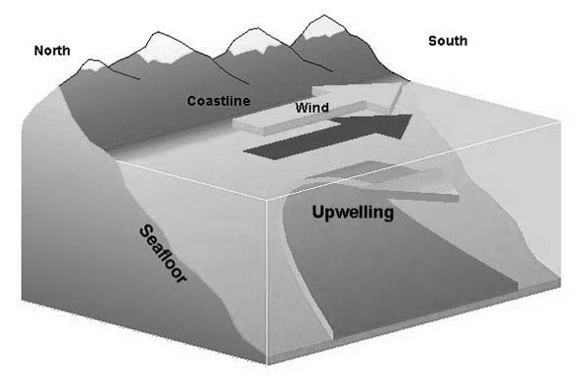
Biological Oceanography
- Kelp forests exist where ___________________ brings cold nutrient rich water to the surface.

