Movement of Air
- ___________ is the movement of air from high pressure to low pressure
  - Named for direction they come from
- Cold air near poles __________ and spreads (pushing less dense, warmer air up)
- _______________ effect
  - Northern hemisphere – clockwise
  - Southern hemisphere – counterclockwise
Doldrums
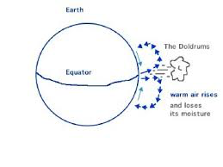
- _______________ – windless area near equator
  - Hot air just rises straight up
  - Trapped many sailing ships
  - Positions change with the seasons based upon the Earth’s position relative to the sun.
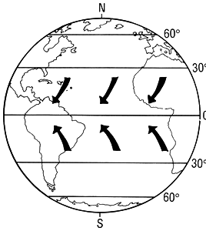
Trade Winds
- ______________________ – major winds in the tropics that move toward equator and west
  - Provided dependable trade routes from Europe
Westerlies
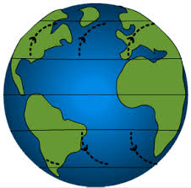
- _______________________________ —between 30° and 60° latitude, opposite direction of trade winds (they come from the west)
  - Took sailors back to Europe
  - Causes most weather patterns in USA
Polar Easterlies
- _______________________ —near poles, winds move toward equator and west (from the east)
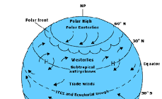
  - Dry, cold winds

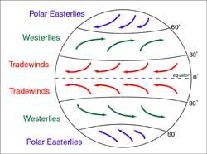

Jet Stream
- ___________________ —narrow belts of strong winds near top of troposphere
  - 60 mph to 110 mph
  - Helpful to jet pilots, if used well
Daily Winds
- Change predictably during the day
  - ____________________ – wind comes in from the sea during the day
    - Land is warmer than sea
  - ____________________ – wind goes out from the land during the night
    - Land is colder than sea
Seasonal Winds
- Change direction _________________ with the seasons
  - ________________ winds over India bring moist air in from sea in summer
    - Bring intense, prolonged rain (wet season)
  - _________________ in winter (dry season)

