Oceanography
The study of the earth's oceans and their _____________________________ ecosystems, geological, chemical and physical processes.
Origins of Water on Earth
- As volcanoes erupted, they spewed lava, ash, _________________, carbon dioxide, and other gases.
- Scientists hypothesize that about 4 billion years ago, water vapor accumulated in Earth’s ____________________.
- After millions of years, it cooled enough to condense into ____________________.
- Torrential rain began to fall and fill ______________, which eventually joined to form _________________.

Amounts of Water on Earth
- _________% of Earth’s Surface is water
  - _________% is salt water
  - _________% is fresh water
- Less than ________% of ALL water on Earth is usable to humans
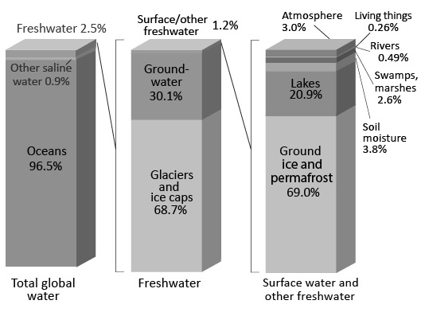

Water on Earth
- Groundwater is stored in _________________________
- Icecaps & Glaciers are found at the ________________ and in _____________________

