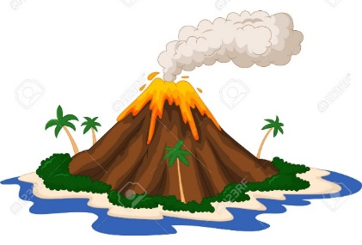
Volcano extra credit
Earth Science classes are being offered an extra credit assignment. If you build and demonstrate a model volcano, you we receive 5 points onto your grade at the end of the marking period! Here are the rules:
- This is an individual project and not a group project.
- You must be able to show me pictures of the student building the project (on their phone is okay).
- Projects must be in class and demonstrated on Thursday, December 22nd. No projects will be accepted after Thursday, December 22nd.
- The student must be able to explain how it was constructed and how it works.
- The project must be completed at home. No class time will be given to work on the project.
You must ALSO pick an actual “real-life” volcano that fits the type you chose and research it (1-2 paragraphs). It may be typed or NEATLY hand written. Answer the following questions about it:
- -Where is it, what is it named
- -How was it formed?
- -When did it last erupt, and what is the eruptive force
- -What were the results of eruption?

Volcano extra credit
Earth Science classes are being offered an extra credit assignment. If you build and demonstrate a model volcano, you we receive 5 points onto your grade at the end of the marking period! Here are the rules:
- This is an individual project and not a group project.
- You must be able to show me pictures of the student building the project (on their phone is okay).
- Projects must be in class and demonstrated on Thursday, December 22nd. No projects will be accepted after Thursday, December 22nd.
- The student must be able to explain how it was constructed and how it works.
- The project must be completed at home. No class time will be given to work on the project.
You must ALSO pick an actual “real-life” volcano that fits the type you chose and research it (1-2 paragraphs). It may be typed or NEATLY hand written. Answer the following questions about it:
- -Where is it, what is it named
- -How was it formed?
- -When did it last erupt, and what is the eruptive force
- -What were the results of eruption?

