Chapter 10 – Plate Tectonics
Continental Drift
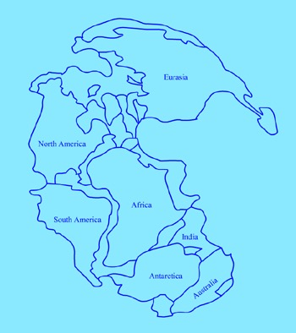
- The ___________________ ______________ hypothesis – continents have moved slowly to their current locations.
- All continents were once connected as one large landmass now called _________________.
- The land mass broke apart, and the ___________________ drifted to their present positions.
- Evidence for continental drift:
- ______________________ of the continents
- Similar __________________ have been found on different continents.
- Remains of warm-weather plants in ____________________ areas and glacial deposits in ____________ areas suggest that continents have moved. (____________________)
- Similar ____________ structures are found on different continents.

Seafloor Spreading
- Using _________________ waves, scientists discovered a system of underwater mountain ranges called the mid-ocean ridges in many oceans.
- In the 1960’s, Harry Hess suggested the theory of _____________________________________ to explain the ridges.
- Hot, less dense material below Earth’s ________________ rises upward to the surface at the mid-ocean ridges.
- Then, it flows sideways, carrying the __________________ away from the ridge.
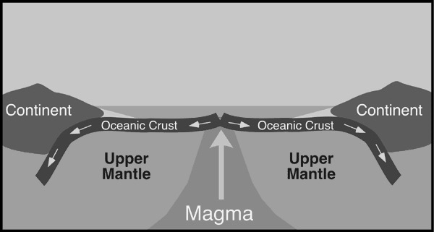
- As the seafloor spreads apart, __________________ moves up and flows through the cracks, cools, and forms new seafloor.
- Evidence for seafloor spreading:
- ____________________ rocks are located at mid-ocean ridges.
- Reversals of Earth’s ______________________ field are recorded by rocks in strips parallel to ridges.
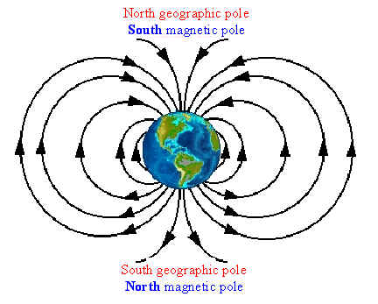
Theory of Plate Tectonics
- Plate movements
- Earth’s _______________ and upper mantle are broken into sections, called __________________, that move on a plastic-like layer of the mantle.
- The plates and upper mantle form the ______________________.
- The plastic like layer below the lithosphere is called the _____________________________.
Note: The theory of plate tectonics shows that sections of the seafloor and continents move around in relation to one another.
- It’s not just the continents or land masses that are moving like Wegener thought.
- Plate boundaries
- ____________________________
  - Occur when 2 plates are moving _____________ from one another.
  - These forms rift valleys and increase seafloor surface area (creates new crust).
- ____________________________
  - Plates moving ______________________
    - Denser plates sink under less _______________ plates
    - Newly formed hot ______________ forced upward forms volcanic mountains.
  - This type of movement causes a decrease in total crust area.
  - Three types of convergent boundaries
    - _____________________________: When an oceanic and continental plate collide. The area where an oceanic plate descends into the upper mantle. Creates deep-sea trenches and volcanoes.
    - __________________________________: Occurs when two ocean plates collide, or when seafloor that has become denser due to cooling begins to skink. Deep-sea trenches form here. New magma rises and can create island arcs from volcanoes.
    - _________________________________: Usually no subduction occurs since both plates are less dense than the mantle layer below. The plates form mountain ranges and earthquakes can occur.
- _______________________________
  - Occurs when two plates slide past one another and are moving either in opposite directions or in the same direction at different rates.
  - Crust is not formed or destroyed
  - Earthquakes often occur here. Ex: San Andreas Fault.
- Plates collide
  - Plates crumple up to form ________________________ ranges
  - ________________________ are common
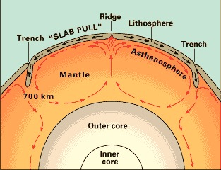
- Convection inside Earth – the cycle of heating, rising, cooling, and sinking of material inside Earth is thought to be the _____________ behind plate tectonics.
- Features caused by plate tectonics
- Faults and __________ valleys
- Mountains and _____________
- Strike-slip faults – cause of _______________
- Testing for plate tectonics – scientists can measure ______________________ as little as 1 cm per year.

