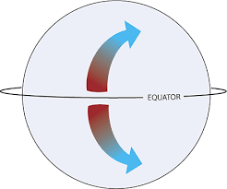
What drives ocean currents?
- __________________
- __________________
- __________________

Coriolis Effect
- Results from __________________ _______________________ and influences ________________ _____________________.

Surface Currents
- Ultimate reason for world’s surface ocean currents is the ___________.
  - Earth is heated by the sun.
  - Wind blows over the _______________________ .
  - Energy is transferred from wind’s energy
  - Push creates surface currents.

Direction of Surface Currents
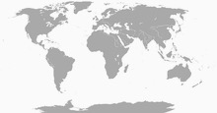
- Along the west coasts of continents, currents flow toward the ________________________.
  - _______________________________ - bring cool water from the polar regions into the tropical region.
- Along the east coasts of continents, currents flow from the equator toward the ____________________.
  - ____________ ______________ - brings the warm tropical water toward the poles.

- A _______________ is a large circular current
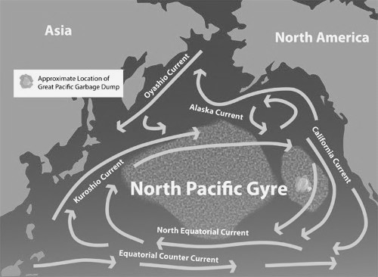
Tidal Currents  - Tides move across Earth, encounter ___________________ and ______________________________, and results in tidal ______________________ which are extremely fast especially when the tidal range is large.  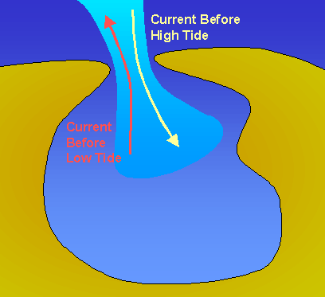 | At the Beach!  - Currents can flow:  - _____________________ - long-shore  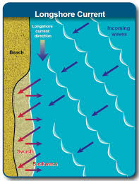  - ___________________________ - rip currents  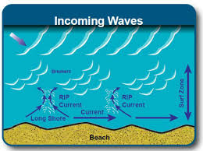
Deep Ocean Currents  - _______________________ caused by differences in water:  - __________________________  - __________________________  - __________________________  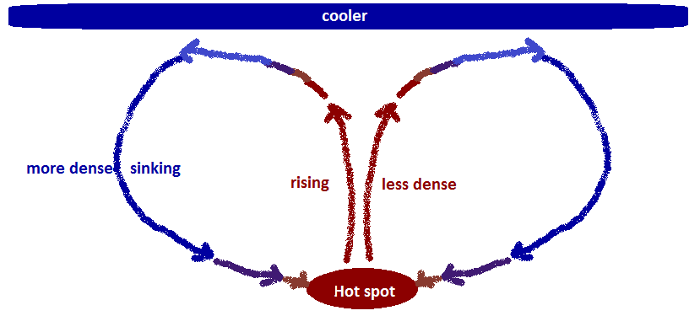 | Upwelling  - Upwelling occurs when cold ______________ and _______________ rich water comes to the surface to replace water that has been moved off the coast by winds.  