What drives ocean currents?  - __________________  - __________________  - __________________ | - Coastal and sea floor features influence their ____________________, _____________________, and _______________________
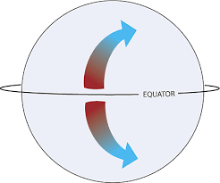
Coriolis Effect
- Results from __________________ _______________________ and influences ________________ _____________________.

Surface Currents
- Ultimate reason for world’s surface ocean currents is the ___________.
  - Heating of the Earth by the __________ creates semi-permanent pressure centers near the ________________________
  - Wind blows over the _________________________ around pressure centers.
  - _____________________________________________ are generated by transferring some of wind’s _________________________
  - This push on the surface of the ocean forms the _______________________________________

Direction of Surface Currents
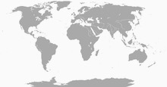
- Along the west coasts of continents, currents flow toward the ________________________.
  - _______________________________ - bring cool water from the polar regions into the tropical region.
- Along the east coasts of continents, currents flow from the equator toward the ____________________.
  - ____________ ______________ - brings the warm tropical water toward the poles.

- A _______________ is a large circular current
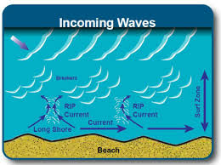
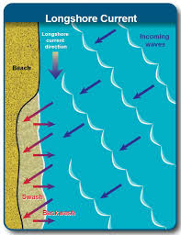
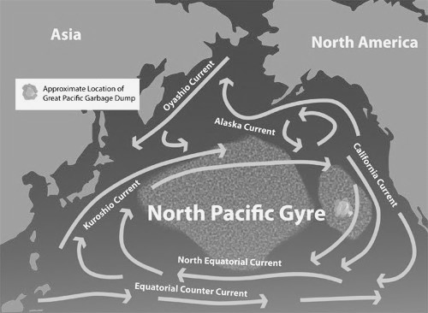
Tidal Currents  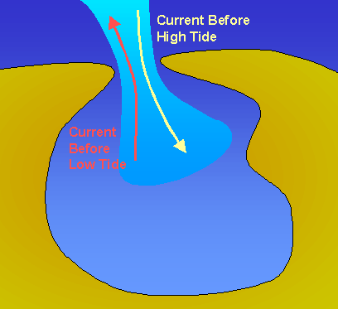  - Tides move across Earth, encounter ___________________ and ____________________, and results in tidal ______________________ which are extremely fast especially when the tidal range is large. | At the Beach!  - Currents can flow:  - _____________________ - long-shore  - ___________________________ - rip currents  - They are influenced by ___________ ______________________________________
Deep Ocean Currents  - ________________________________________  - _______________________ caused by differences in water ___________________, and resulting from difference in water _________________________ (thermo) and _________________________  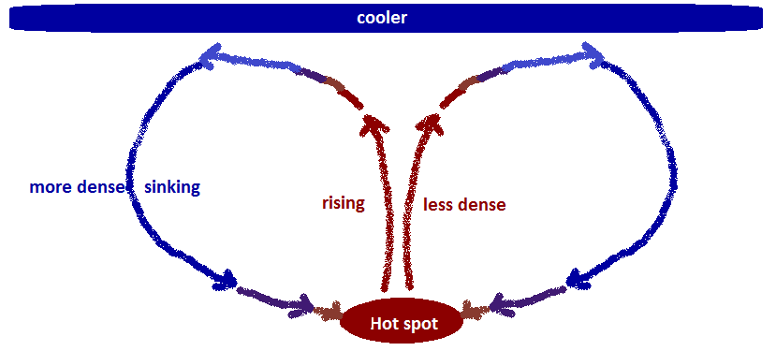 | Upwelling  - Upwelling occurs when cold ______________ and _______________ rich water comes to the surface to replace water that has been moved off the coast by winds.  - Supports many ___________________________ and ____________________________________  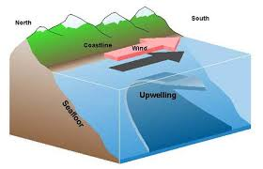

Global Conveyer Belt
- A connected system of __________________ and _______________________ currents that circulate around the globe on a 1000 year time span.
- Critical part of:
  - Earth’s _____________________________ system
  - Ocean _________________________ and carbon dioxide cycles

