Atmospheric Gases

We learned about the composition of the Earth’s atmosphere. If we break down the percentages to numbers it would be equal to 78 beads for Nitrogen, 21 beads for Oxygen, and 1 bead for other stuff. Count out the number of beads from the bag labeled “original” and place them in the bag labeled “Earth’s Atmosphere.”

Bag 1 |  |  | Bag 2
Nitrogen | Black |  | Nitrogen | Pink
Oxygen | White |  | Oxygen | Purple
Other stuff | Green |  | Other stuff | Green

When you are done draw a picture of your bag under Atmospheric Gases and then return the beads to the original bags.

Atmospheric Layers

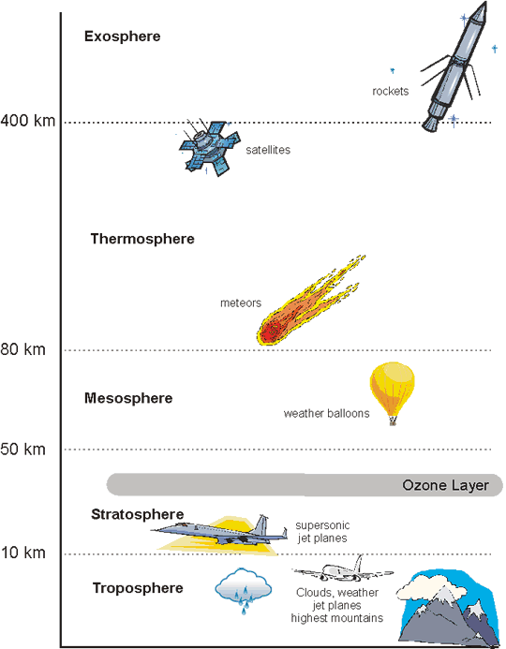
We learned about the order of the Earth’s Atmospheric Layers. Use the Play-Doh to put the layers of the atmosphere in order from lowest to highest. Use the correct pop-sickle sticks to label each layer.

Draw a picture of your model under Atmospheric Layers and then return the Play-Doh to the correct containers. DO NOT MIX THE PLAY-DOH.

Atmospheric Layers - Thickness
We learned about the order of the Earth’s Atmospheric Layers and that each layer has a different thickness. Using the picture and the pop-sickle sticks, model the thickness of each layer. Each stick represents 10 km. Start with the Troposphere, which is 10 km thick, and count out the number of sticks you need. Next is the Stratosphere, which is 40 km thick (50 km – 10 km = 40 km). Count out the number of sticks needed for this layer. Continue to do this for the rest of the layers. Do not forget to include the ozone layer in your model.

Draw a picture of your model under Atmospheric Layers-Thickness.

Atmospheric Pressure
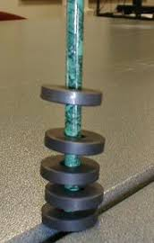
We learned about Earth’s Atmospheric Pressure. If you were to add magnets to a pencil as shown in the picture to the right, you would be able to notice the spacing between the magnets.

If you were to push one magnet toward the other you would notice the magnetic repulsion that would push the magnets away from each other again.

What do you notice about the spacing between the magnets at the bottom of the pencil?

What do you notice about the spacing between the magnets at the top of the pencil?

How does this explain atmospheric pressure?

After you have discussed this with your group, write them under the section labeled Atmospheric Pressure.

Atmospheric Layers | Atmospheric Layers – Thickness
Atmospheric Gases

Atmospheric Pressure
What do you notice about:
a. the spacing between the magnets at the bottom of the pencil?

b. he spacing between the magnets at the top of the pencil?

How does this explain atmospheric pressure?
Atmospheric Layers | Atmospheric Layers – Thickness
Atmospheric Gases

Atmospheric Pressure
What do you notice about:
a. the spacing between the magnets at the bottom of the pencil?

b. he spacing between the magnets at the top of the pencil?

How does this explain atmospheric pressure?

