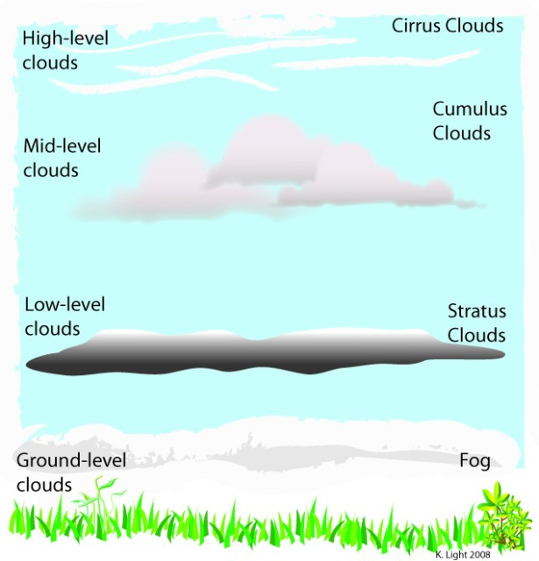
What is Weather?
- Weather is the ______________ ____________ of the atmosphere
- This includes:
    - Air pressure
    - _______________
    - Temperature
    - _______________

What is Humidity?
- Humidity is the amount of _____________ in the air
- ____________ ____________ – the amount of water in the air compared to how much it could hold
    - _____________ air can hold more water than ____________ air
    - Saturated – 100% humidity
- _________ ___________ – temperature at which air is saturated and condensation occurs

What are clouds?
- Clouds are small drops of __________ floating in air – formed as ___________ air is forced up, and the water vapor cools
- _________ ___________ collects around small particles of dust, salt, and smoke (called a cloud nuclei)
- Classified by _____________ and ___________
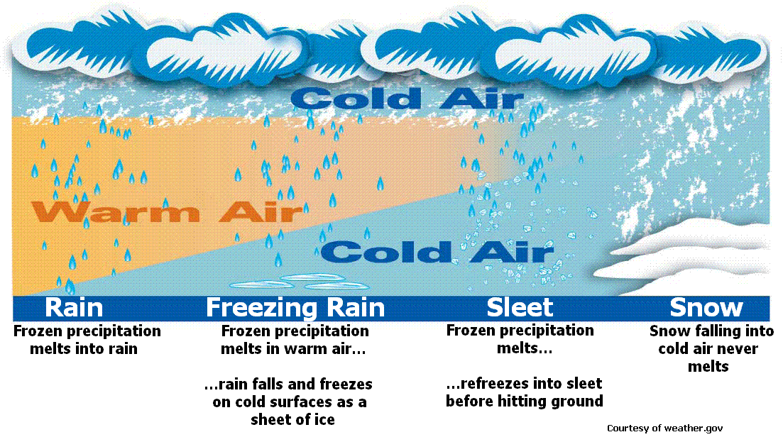

Precipitation
____________ | Drops of water; fall when air is above freezing
____________ | Ice crystals form in clouds
____________ | Snow passes through warm air, melts, then refreezes near the ground
____________ | Recycled sleet gathering additional layers of ice

Clouds - Stratus
- Form ___________, ____________ layers; made when air cools below dew point
Form at _________ altitudes
Bring light drizzle
When air is cooled and condenses near ground – called __________

Clouds - Nimbus
- Dark clouds associated with ___________________
Saturated with water

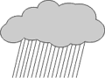

Clouds – Cumulous
- Puffy white clouds with flat bottoms
Formed when air currents _________
Large ones are major _____________ clouds (cumulonimbus)

Clouds – Cirrus
- Thin, high, white and _____________ looking
Made of _______ crystals
Associated with ________ weather

