- The ability for the ocean to absorb and store energy from the sun is due to:
  - The transparency of the water that allows the sun’s ray to penetrate deep into the ocean.
  - Constant turbulence from wind and weather mixes the water, distributing surface heating throughout
- Composed of two opposing flows
  - One at the surface (called sea breeze)
  - One aloft (a return flow)
- Two flows are a result of the difference in air density between the land and sea caused by the sun’s heating.
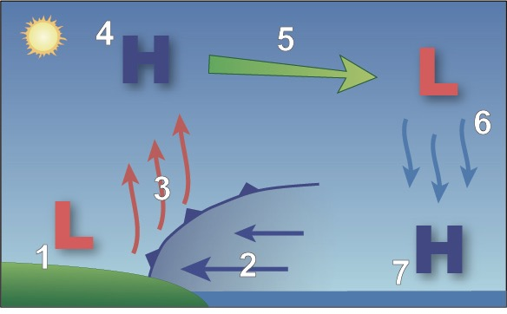
Sea Breeze
- Sun warms ground and ocean, ground’s heat radiates into atmosphere, warming air. As air warms, density decreases creating a weak low pressure area called a “thermal low”
- The cooler, more dense air from water, spreads inland.
- Air from ocean undercuts less dense air over land forcing it to rise. (Sea breeze front - develops due to the large difference between the air temperature over land and over water)
- Air begins to cool, density increases, forms small area of high pressure (Occurs from 3,000 to 5,000 feet in elevation.)
- High pressure/density air flows back over water (where there is low air pressure/density)
- Air cools, density increases, air sinks toward the earth’s surface
- Enhances high pressure near the ocean’s surface.

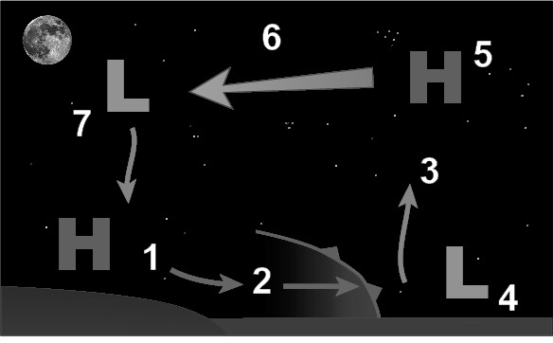
Land Breeze
- Land temperature falls below ocean temperature resulting in increase in air’s density. Gravity’s pulls dense air offshore.
- More dense air undercuts the lighter, warmer air over water.
- Forces air up into the atmosphere
- Raising air from a weak low pressure area.
- Rising air accumulates aloft forming an area of higher pressure
- Air flows back toward land from high pressure to low pressure
- Air cools, increases in density, then sinks causing an increase in density and high pressure.

Land Breeze Weaker than Sea Breeze
- At night:
  - Cooling ground inhibits vertical motion which weakens the land breeze circulation
  - Nighttime cooling produces a shallower change in temperature so land breeze circulation is shallower
  - Terrain, vegetation, and buildings inhibit the flow of air from land to water.

