Name: _________________________
Date: _________________________
Period: _________________________
Transfer of Heat/Water Cycle Review

- What is the source of all energy?

- What is the transfer of energy through electromagnetic waves?

- What is the transfer of energy through direct contact?

- What is the flow of heat by movement of gases and liquids?

- Which form of heat transfer causes weather?

- An iron coming in direct contact with clothes transfers heat through ____________________.

- The Earth’s Mantle is an example of which type of heat transfer?

- A person placing their hand over a hot fire is which type of heat transfer?

- A microwave can be used in which type of heat transfer?

- The air flow in a vent can be used in which type of heat transfer?

- The term used to describe water turning to water vapor is ______________________.

- Water vapor cooling to form clouds is called ___________________________.

- The evaporation of water from plant leaves is called ____________________________.

- The movement of water on land to rivers, lakes, streams, or oceans is called _______________________.

- Cooled water falling back to Earth is considered ___________________________.

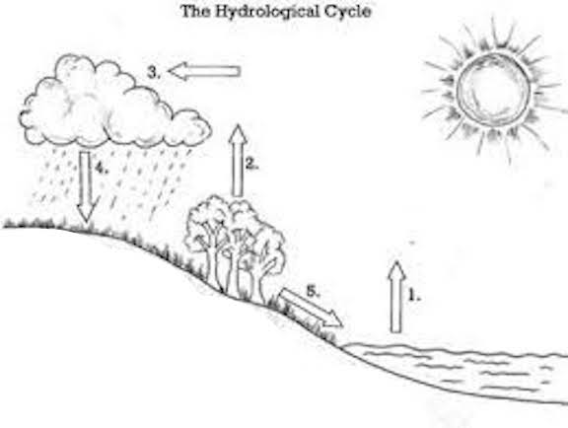
Name the parts of the water cycle
- #1 is _______________________
- #2 is ________________________
- #3 is ________________________
- #4 is ________________________
- #5 is ________________________

Word bank
Runoff
Evaporation
Transpiration
Condensation
Precipitation

