Parts of a wave:
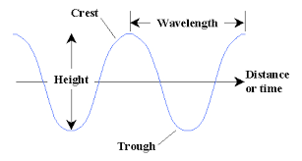

Wind and Waves
- Wind produces currents
- __________________________________________
  - As waves form, surface becomes rougher
  - Then becomes easier for wind to grip the surface and intensify waves
- Wave height is affected by:
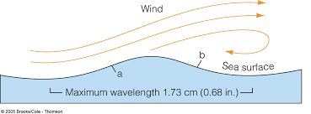
  - ________________________
  - ________________________
  - ________________________
- Waves on the beach are affected by:
  - ________________________
  - ________________________

Ocean Wave
- Characteristics
  - Period: _________________________
  - Wavelength: ____________________
  - Speed: _________________________
- Characteristics of rogue waves:
  - Height is greater than twice the size of surrounding waves
  - Often come unexpectedly from directions other than prevailing wind and waves
  - Are unpredictable

Tsunami
- Is a series of ocean waves __________________________________________________ ________________________________________________________________________
- In the deep ocean, they do not dramatically _____________ in height
- As they travel inland, they build up to _______________ and ______________ heights as the depth of the ocean __________________
- Speed depends on the ocean depth, not _________________ from source
- Characteristics
  - Period: _________________________
  - Wavelength: ____________________
  - Speed: _________________________
