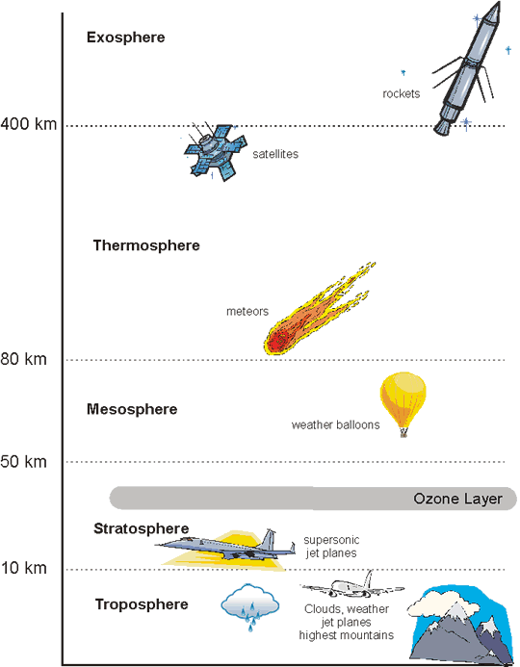
Exosphere
- _______________________________ orbits here
- Gradually trails off into ______________________________

Thermosphere
- Contains _________________________:
  - electrically charged part

Stratosphere
- Contains ______________________ layer

Troposphere
- 75% of the _______________________________________ and particle matter

Atmospheric Temperature
- In _________________________, temperature _______________________ as you go higher up
- Warmest layer is actually the uppermost ______________________________

Atmospheric Gases
- Major gases
  - ___________% Nitrogen
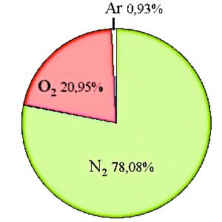
  - ___________% Oxygen
  - ___________% other stuff
    - ____________ % Carbon Dioxide

Atmospheric Solids and Liquids
- _____________________________
  - Wind picks it up
  - Smog
- _____________________________
  - from ocean spray
- _____________________________
  - snowflakes, hail

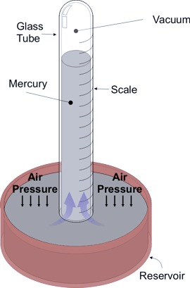
Atmospheric Pressure
- ___________________ ___________________: weight of air above you
- Pressure is greatest at ___________________
- ___________________ the higher up you are
- Colder air is __________________ (greater pressure)
- Hotter air is ___________________ (less pressure)

The Ozone Layer
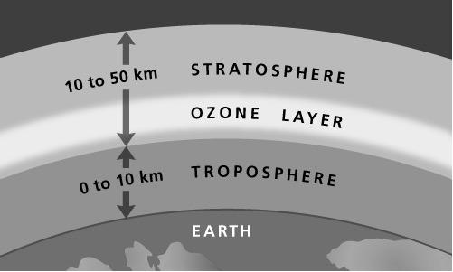
- High concentrations of ________________ 20 km up
- Ozone – 3 __________________ atoms (O₃)
  - Regular oxygen we breathe is _______
- Absorbs ______________________ _______ radiation
  - High UV exposure causes _________ _________
- Holes in the layer developed over _______________

Ozone Depletion
- _____________________________________________
  - Chlorine, Fluorine, and _____________
  - Uses
    - Propellant in aerosol cans
    - _____________________
    - Refrigerators and air conditioners
  - Break up _________________ molecules in the air

